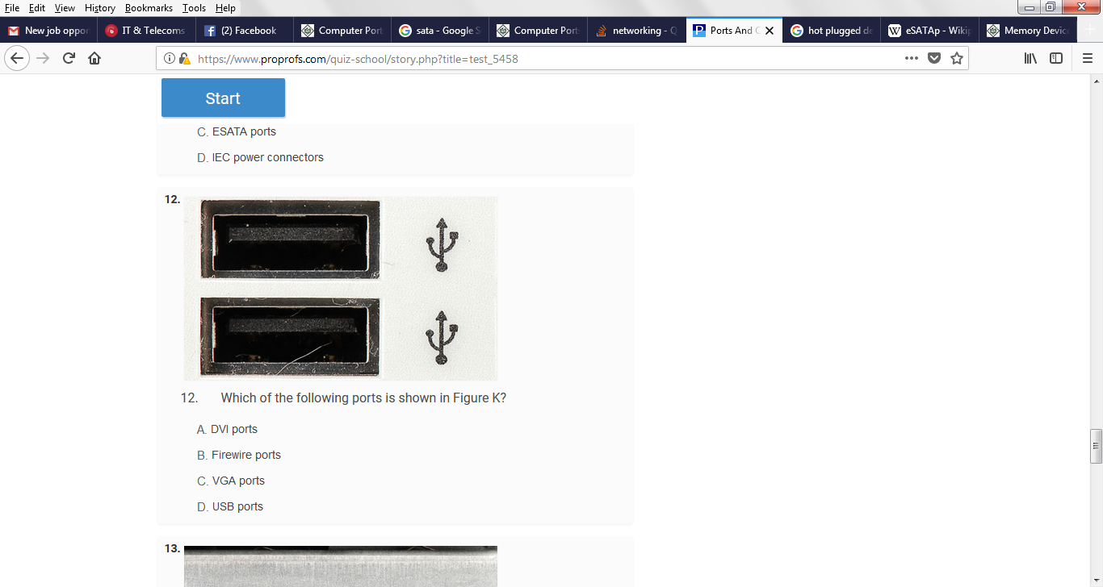

IEC power connector

**Types of RAM**

SRAM (Static RAM):

* Fast and has less access time.
* Consists of flip-flop using either transistor or MOS (Mosfet).
* For each bit it requires one flip-flop.
* Status of each bit remains as it is unless there is write operation or power is off.
* e.g. Cache memory.
* Advantages   
  Refreshing circuit is not required.
* Disadvantages   
  Costly and low package density.   
  Requires more space.

DRAM (Dynamic RAM):

* Slower and higher access time
* Data is stored in the form of capacitors.
* Capacitors charges when data is 1 and doesn't charge if data is 0.
* Because of leakage current in capacitor, they need to be refreshed to hold the data in memory cells.
* Refreshing is the process in which the contents of each memory cell is read and written hundred times a second.
* This maintains the data of memory cells in capacitor.
* e.g. Main memory.
* Advantages   
  Cheaper than static RAM.
* Disadvantages   
  Requires refreshing circuit.

[Briefly tell me how computers have affected your life as a student.](https://www.proprofs.com/discuss/q/778819/briefly-tell-me-how-computers-have-affected-your-life-as-stu)